Name……………………………………………………Adm No…………………. Class ...............
PHYSICS
FORM 2
MAY 2022
TIME: 2 HOURS

MID TERM 1 2022 EXAM

INSTRUCTIONS TO CANDIDATES
- Write your name and admission number in the spaces provided above.
- This paper consists of TWO sections: A and B
- Answer All questions in section A and B in the space provided.
- Show all the steps in your calculations, giving your answers at each stage in the spaces below each question.
Where necessary take:
- Earth’s gravitational intensity=10N/kg
- Density of water= 1000kg/m³

SECTION 1 (40 MKS)
Answer all the questions
- (i)Define length (1mk)
………………………………………………………………………………………………………………………………………………………………………………………………………..
(ii) State the most appropriate measuring instrument you would use to carry out each of the following measurements.
(a). Length of football field. ……………………………………… (1mk)

(b). Relative density of a liquid. ………………………………….. (1mk)

- (i) What is a basic quantity? (1mk)
……………………………………………………………………………………………………………………………………………………………………………………………………….
(ii) State two examples of a basic quantity and their SI units. (2mks)
…………………………………………………………………………………………………………………………………………………………………………………………………………………...
- A plot of land is represented on a map by an area of 48.5cm². If the scale on the map is 1:5000, determine the actual area of the land in square meters.
………………………………………………………………………………………………………………………………………………………………………………………………………………………………………………………………………………………………………………………………………………………………………………………………………………………………………
- When a narrow glass tube is dipped in a beaker containing water, the water rises up the tube.
  - What is the name given to this effect? (1mk)

……………………………………………………………………………………………….

  - Explain the observation (1mk)
………………………………………………………………………………………………………
- State the two factors affecting the surface tension of a liquid. (2mks
……………………………………………………………………………………………………………………………………………………………………………………….

- The atmospheric pressure at a place was measured as 740mm of mercury. Calculate the pressure at the place in Pascals. (density of mercury is 13.6g/cm³) (3mks)
…………………………………………………………………………………………………………………………………………………………………………………………………………
- Explain how a drinking straw works when used to drink a liquid.
…………………………………………………………………………………………………………………………………………………………………………………………………………………………………………………………………………………………… (2mks)
- State the kinetic theory of matter.
………………………………………………………………………………………………………………………………………………………………………………. (1mk)

- a)
In the smoke cell experiment, the bright specks (smoke particles) are observed to be in a continuous random motion. Explain the cause of the motion.
…………………………………………………………………………………………………………………………………………………………………………………………………… (1mk)

(b) State and explain the effect on the motion of the particles when the temperature of the smoke cell is increased
........................................................................................................................................................................................................................................................................................................(2mks)

- (i) What is diffusion?
……………………………………………………………………………………………………………………………………………………………………………………………… (1mk)

(ii) State two factors affecting the rate of diffusion of a gas (2mk)
…………………………………………………………………………………………………………………………………………………………………………………………………………….

- State any three differences between mass and weight.
………………………………………………………………………………………………………………………………………………………………………………………………………………………………………………………………………………………………………(3mks)
- An object has a mass of 120g.what is the weight of the object at the moon surface? (gravitational intensity of the moon is a third that of the earth)
………………………………………………………………………………………………………………………………………………………………………………………………………………………………………………………………………………………………………………………………………………
(2mks)
- The water level in a burette is 40.6cm³. 50 drops of water each of volume 0.2cm³are added to the water in the burette. What is the final reading of the burette?
……………………………………………………………………………………………………………………………………………………………………………………………………………………………………………………………………………………………………………
(3mks)
- On the axis provided, sketch a graph of volume against temperature of water from 0º to 20ºC.
(2mks)
Temperature (ºC)
Volume (cm³)

- It is easier to detect a bad smell from a gaseous substance than a solid substance. Explain
…………………………………………………………………………………………………………………………………………………………………………………………………………………..
(1mk)

SECTION B (60 MARKS)
- a) State three uses of electroscope (3mks)
…………………………………………………………………………………………………………………………………………………………………………………………………………………………….
- Fill in the table of charges appropriately ( 3mks)
Charge on Electroscope | Charge on a rod brought near cap | Effects on leaf divergence
+ | +
- | +
+ or - | Uncharged body

- What is the name given to the method of charging an electroscope where it acquires an opposite charge to the one of the charging materials? (1mk)

……………..……………………………………………………………………………………
……………..……………………………………………………………………………………
- A plastic comb is rubbed with a duster. Small pieces of paper stick to the comb as it gains a charge.
(i) Suggest why the small pieces of paper stick to the charged comb. (1mk)
.................................................................................................................................................................................................................................................................................................................................
(ii) Small pieces of paper will not stick to a hand held metal comb rubbed by a duster. Why not? (1mk)
...................................................................................................................................................................................................................................................................................................................................
- a) Karen wants to pump up her car tyre. Her pump has a piston with an area of 7 cm².
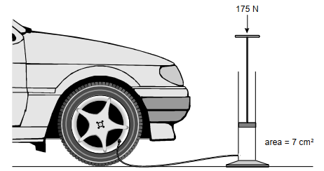

Karen pushes the handle down with a force of 175 N.
(a) What pressure does she exert on the air in the pump? (3mks)
...............................................................................................................................................................................................................................………………………………………………………………………………………………………………………………………………………………………………………..
(b) What pressure would be exerted in the tyre by the pump (1mk)
...............................................................................................................................................................................................................................................................................................................................................
(c)
One of the Karen’s car tyres exerts a pressure of 25 N/cm² on the road. The area of the tyre in contact with the road is 95 cm². What is the force exerted by four tyres on the road? (3mks)
.......................................................................................................................................................................................................................................................................................................................................................................................................................................................................................................................
d) State three properties of hydraulic brake fluids. (3mks)
………………………………………………………………………………………………………………………………………………………………………………………………………………………………………………………………………………………………………………………………………………
- Define the term temperature and state its SI units (2mks)
…………………………………………………………………………………………………………………………………………………………………………………………………………………………………………
(b) Convert each of the following from Kelvin to degree Celcius (2mks)
(i) 0 K

(ii) 167 K

(c) State the two special features of a clinical thermometer (2 hmks)
………………………………………………………………………………………………………………………………………………………………………………………………………………………………………………
(d) Give a reason why a clinical thermometer should never be sterilized using boiling water (1mk)
……………………………………………………………………………………………………………………………………………………………………………………………………………………………………………..
- (a) The figure below shows a liquid-in-glass thermometer.

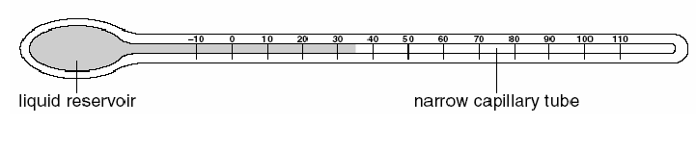
(i) Name a suitable liquid to use in the thermometer. 1mk
....................................................
(ii) State the reading on the thermometer. ............................... °C 1mk
(iii) Explain why a narrow capillary tube is used. 1mks
....................................................................................................................................................................................................................................................................................................................................

(b) The thermometer bulb is put in melting ice.
(i) Explain why the liquid drop7s in the capillary tube. 1mk
.....................................................................................................................................................................................................................................................................................................................................
(ii) Mark on the diagram the new position of the liquid. 1mk
………………………………………………………………………………………………………

c) Logs of wood are burning in a camp-fire on the ground. A person is sitting nearby.

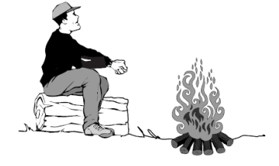
(i) State the main method of heat transfer by which energy from the fire reaches the person
sitting nearby. (1mk)
........................................................................................................................................

ii) A spark jumps out of the fire. The spark lands on the person’s hand. State which method of heat transfer causes the person to feel the spark. 1mk
.................................................................................................................................

- a) State the property of light associated with formation of shadows. (1mk)

b)
The diagram shows a lamp and a piece of cardboard. The piece of cardboard has a hole in it. Light from the lamp passes through the hole and forms a bright spot on a wall.
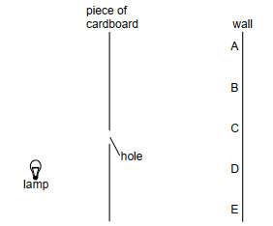

c) (i) Which point on the wall, A B, C, D or E, is lit up by the lamp? 1 mark
………………………………………………………………………………..........................................
(ii) Explain why the other points on the wall are not lit up by the lamp. 1mk
...................................................................................................................................................................
d) A piece of clear green plastic is placed over the hole. What is the colour of the light which shines on the wall? 1mk
............................................…………………………………………………………………………

e) The diagram shows a motorist looking into her plane driving mirror.
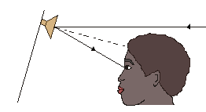
(i)
Mark on the diagram: the letter 'I' to show the incident ray and the letter 'r' to show the angle of
reflection. (2 marks)
(ii) Name the dashed line shown in the diagram. (1 mark)

………………………………………………………………………………………………..

- An object of height 5 m is placed 10 m away from a pinhole camera.
Calculate:
(i) the size of the image if its magnification is 0.01. 2mks

(ii) the length of the pinhole camera. 2mks

- a) Define matter (1mk)
………………………………………………………………………………………………………………………………………………………………………………………………………………….

(b) The following set up was used to observe Brownian motion
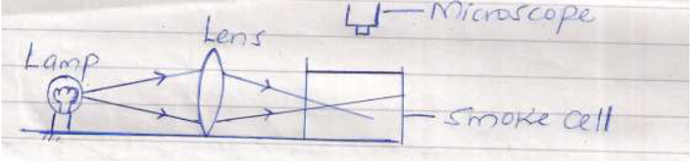
Explain the role of the following:
(i) Lamp (1mk)
……………………………………………………………………………………………………..
(ii) Lens (1mk)
…………………………………………………………………………………………………..
(iii) Microscope (1mk)
……………………………………………………………………………………………………
(c) State and explain the observation made in the smoke cell (3mks)
……………………………………………………………………………………………………………………………………………………………………………………………………………………
(d)
What will be the effect of increasing the temperature of the smoke cell on the observations made above? (1mk)

- A ream of foolscaps containing 500 papers has a thickness of 50mm and a mass of 2kg. if it has a width of 200mm and a length of 300mm, find;
- The thickness of one sheet of paper (2 marks)

- The mass of one sheet of paper (2 marks)

- The volume of one sheet of paper (3 marks)

- The density of the paper. (3 marks)

